Tailoring crystallization in oxide glasses: Application to transparent polycrystalline ceramics and nanostructured glass-ceramics
Mathieu Allix¹, Cécile Genevois¹, Emmanuel Véron¹ and Franck Fayon¹
¹CEMHTI, Orléans, France. (mathieu.allix@cnrs-orleans.fr)
Crystallization from glass can be a powerful process to elaborate innovating transparent materials for optical and photonic applications if nucleation and crystal growth steps can be precisely controlled. This talk will focus on two main applications: transparent polycrystalline ceramics elaborated by full and congruent crystallization from glass and nanostructured glass-ceramics designed from nanoscale phase separated glasses.
Transparent polycrystalline ceramics elaborated by full crystallization from glass
Transparent ceramics are an emerging class of optical materials competing with single crystal technology for a broad range of applications. Ceramics offer several advantages, particularly in the fabrication of complex shapes and large-scale industrial production, and enable great and homogenous doping of optically active ions. However, up to date, only a limited number of cubic or nanocrystalline transparent polycrystalline ceramics requiring complex and expensive synthetic approaches has been reported. Our recent work shows the possibility to obtain new transparent ceramics by full and congruent crystallization from glass. This is demonstrated in the case of several new compositions, such as BaAl₄O₇, Sr₃Al₂O₆ and Sr₃Ga₂O₆, all showing high transparency in the visible and infra-red ranges. Lately, we have focused our work on large scale and highly transparent strontium aluminosilicate compositions. A crystallographic study coupled to NMR experiments and DFT calculations of the birefringence evidences the role of structural disorder (Al/Si substitution and presence of vacancies on strontium sites) to explain the optical isotropy observed in these hexagonal materials. These results propose an innovative concept, the addition of a controlled structural disorder within crystalline structures, in order to lower the birefringence and to elaborate new transparent ceramics.
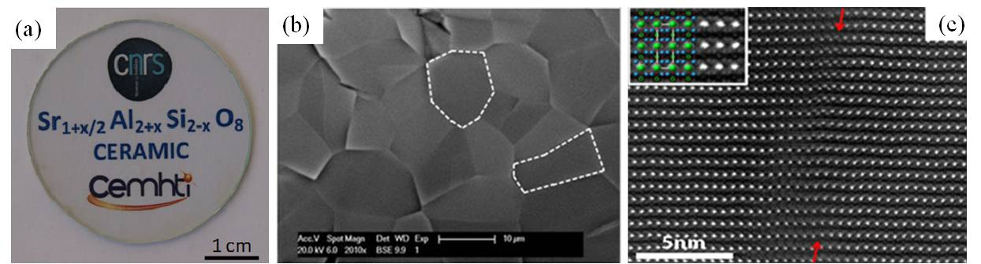
Sr_{1+x/2}Al_{2+x}Si_{2-x}O₈ transparent polycrystalline ceramics elaborated from full glass crystallization.⁵
Transparent nanostructured glass and glass-ceramics
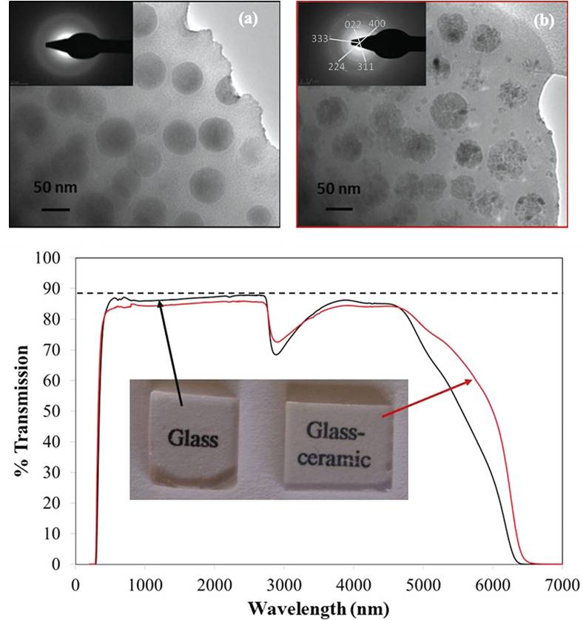
New nanostructured gallogermanate- and gallosilicate-based glass materials exhibiting high transparency in the visible range have been fabricated by conventional melt-quenching. These materials can accommodate wide oxide compositions and present nanoscale phase separation. The size of the nanostructuring can be tailored depending on the nominal composition. A single heat treatment then allows selective crystallization of the phase separated glass, resulting in glass-ceramic materials exhibiting nanostructures and transparency similar to the parent glass [8, 9]. The wide possibilities of designing new nanostructured glass-ceramics with tunable optical properties will be illustrated in the case of a highly transparent ZnGa₂O₄ glass-ceramic exhibiting 50 wt% of nanocrystals with homogeneous and tunable sizes. High resolution scanning transmission electron microscopy analysis coupled with in situ high temperature X-ray diffraction and optical measurements led to a detailed description of the crystallization process. Remarkably, red long-lasting luminescence arising from the entire sample volume is observed in this Cr³⁺ doped material, opening the route to a wider range of performing applications for this famous zinc gallate persistent phosphor [10, 11].
TEM patterns of zinc gallogermanate glass (a) and glass-ceramic (b) materials.
1. M.Allix et al., Advanced Materials, 24 5570-5575 (2012). 2. International patent deposited 1/12/2011, published 6/6/2013. 3. G.Patton et al., PCCP, 16 24824 (2014). 4. M.Boyer et al., J. Mater. Chem. C, 4 3238-3247 (2016). 5. S.Alahraché et al, Chemistry of Materials, 25 4017-4024 (2013). 6. M.Boyer et al. Cryst. Growth Des., 16 386-395 (2016). 7. K.Al Saghir et al., Chemistry of Materials, 27 508-514 (2015). 8. International patent deposited 28/02/2014, published 4/9/2014,. 9. S.Chenu et al. Advanced Optical Materials, 2 364 (2014). 10. S. Chenu et al. J. Mater. Chem. C, 2 10002-10010 (2014). 11. M.Allix et al. Chemistry of Materials, 25 1600–1606 (2013).

