Plasma sputtering synthesis of nanocatalyst for fuel cells: Experiments and molecular dynamics simulations.

Hydrogen powered fuel cells are expected be a relevant solution for green and sustainable energy delivery. Major breakthroughs remain to be achieved. One of them is to lower the noble metal content used as catalysts in the fuel cell electrodes for electrochemical conversion of H₂ and O₂ from air into electricity, heat and water.
Plasma sputtering deposition of supported nanocatalysts has been demonstrated to improve electrode efficiency of low temperature proton exchange membrane fuel cells. Indeed, sputtering can act as an atom source with a controlled energy distribution, which, in turn, enables to control the nanocatalyst growth on the porous carbon electrode with a controlled in-depth profile. This allow to drastically reduce the noble metal content up to a factor 100. Another way is to alloy the noble metal catalyst (here Pt) with a common metal (Fe, Ni, Mo, …) and also with gold. The latter being not a catalyst but is expected to prevent nanocatalyst sintering during fuel cell operation. Very recently, direct growth of Pt alloy nanocatalyst in the plasma phase have been carried out using gas condensation source leading to well defined and narrow nanocluster size distributions.
As the nanoparticle growth by sputtering methods is atomic by nature, simulations at the molecular level are expected to be relevant for understanding basic mechanisms of this deposition method. Indeed, molecular dynamics (MD) as being able to exactly calculating the trajectory of atomic systems is a suitable method for addressing this topic, especially in the context of plasma sputtering. Very recently, it has been shown that MD simulations allowed confirming and predicting the morphology and structure of Pt nanocatalysts as well as for Pt_{x}Pd_{y}Au_{z} and Pt_{x}Ni_{y}Au_{z}. Direct growth in the plasma phase mimicking the gas condensation source is also studied. Initial conditions of MD simulations are selected for matching experimental chemical and physical methods. Radial distribution functions and X-Ray Diffraction pattern are systematically computed for enabling direct comparison with experiments.

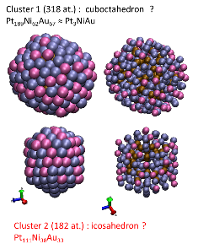 | 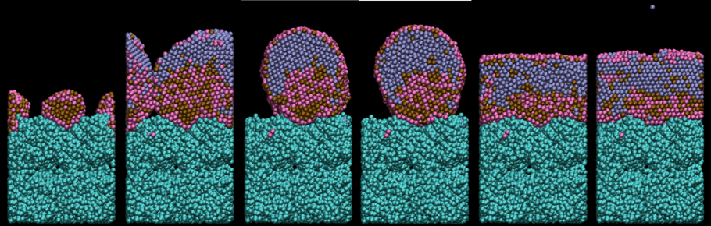
Pt₃NiAu free nanocatalysts grown in argon | PdAu@Pt₂ core-shell nanocatalyst grown on model porous carbon. evolution against increasing deposition time (from right to left)

